Department of Computer Science

Silicon Valley University

Internet of Things

Personal Assistant – Group Project Idea

Bharadwaj Tippabhotla A2885

***Abstract*** *–* In this group project, we have presented the idea of personal assistant, which can be helpful in assisting a person in day to day activities and also in some aspects in your shopping and financial matters too. This personal assistant is supposed to be designed in such a way that it is easy to install and make use of it on any device. This should also have the capability to talk to other personal assistants and also to a computer where it can save the data.

Key terms – Wi-Fi, personal assistant, Angular.JS

**Introduction**

Individual Assistant is a Wi-Fi associated, voice worked PC that permits you to stay in contact with family, companions, and the Internet totally hands free through voice. It brings custom voice cooperation into your home so you can send messages, play music, control Internet associated gadgets, and do practically anything without expecting to get your telephone or get to a PC. It's generally on and prepared.

So, it needs to communicate with various devices and keep itself updated so that it can be useful to make itself as a personal assistant.

**Problem Statement**

Suppose there is a family. When the wife and the husband went to shopping individually, for grocery, then they have to make sure that they don’t buy duplicate items and also don’t forget any item in a given list of things. So, in those scenario, they may maintain a list of commodities they need to buy but, how they make sure that they are not buying the duplicated grocery. In those scenario our proposed idea of personal assistant will certainly come in handy where it not only keeps in sync between the two users it also communicates to register and pay the money and also checks for any forgotten items.

In the same way to keep track of financial things like credit card payments, due dates, day to day activities our personal assistant can be really helpful to assist in the things.

**Proposed Solution**

There are already available solutions that might meet the given necessity. But, they are configured on various devices and they cannot communicate with each other. Also, not all devices are capable of IOT kind of communication. The following figure shows the IOT capable devices and the personal assistants that are present.

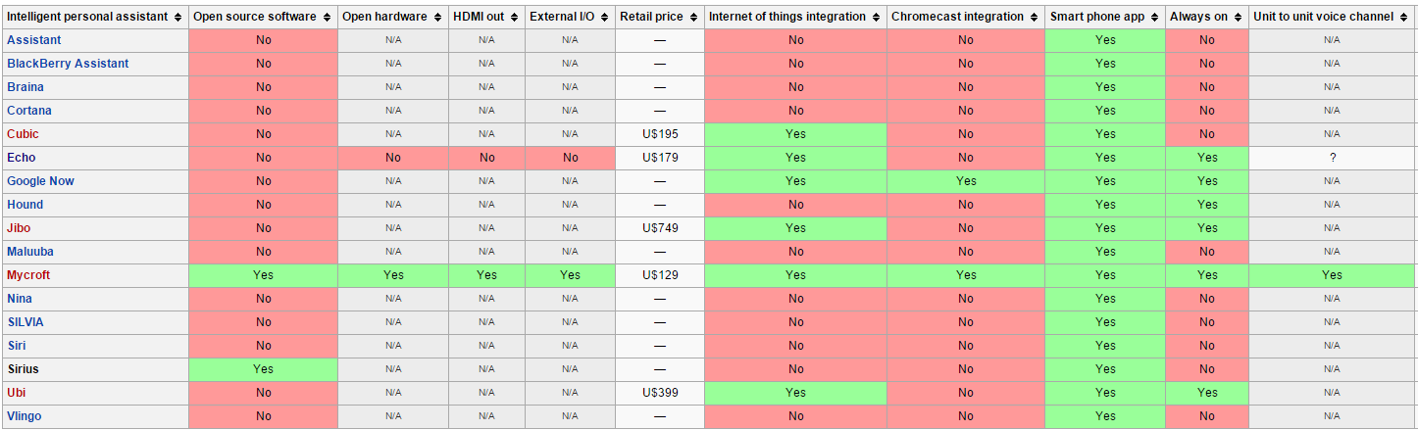

Fig: 1 The table shows list of personal assistants and their specifications and IOT capability

So, as seen from above there are various devices that have the personal assistants and they have their own capability of dealing with IOT. But the system that we want to propose will be completely device independent and has the capability of IOT and also can communicate between themselves and also to the web interface.

The solution that we propose has the capability to respond to various user instructions and also can react to certain orders that might need additional clarification. Some of the tasks that our proposed assistant can do are listed here under.

* Answering basic inquiries
* Play Music
* Set Alarm and
* Task update
* Pay your bills
* Emergency
* Diet Tracker
* Order Food
* Read Book
* Online Shopping
* Appliances that are controlled

**Flow process for personal assistant**

The following figure shows the flow process that how the communication to various interconnected devices is going on.

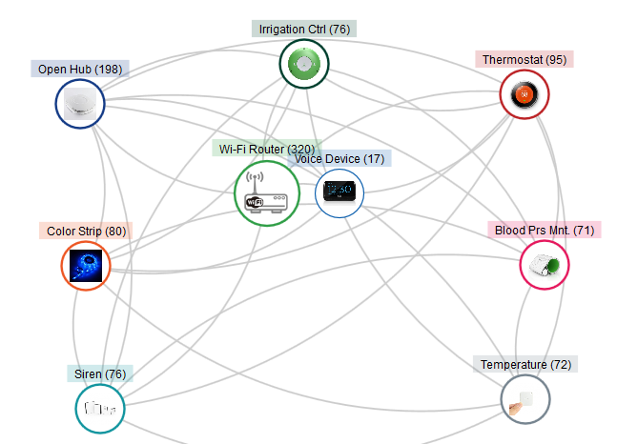

**Fig 2: Interconnectivity of Devices**

The prosed way to interact with the personal assistant is shown below with appropriate sequence that the assistant is capable off.

1. Give Voice Commands to the gadget specifically or through an App
2. Once it has gotten an order it associate with your home switch through WiFi or Ethernet.
3. Sends the order or question to the cloud
4. The cloud sends the sound to two or more online application interfaces (APIs) that make an interpretation of discourse to message (STT).
5. The STT APIs react with a content interpretation of the sound expression
6. The gadget cloud thinks about the outcomes and chooses the best one in view of past execution, reaction time and different variables.
7. The content interpretation is sent to no less than two counterfeit consciousness APIs.
8. The counterfeit consciousness APIs react with an information structure that makes an interpretation of the content into aims, objects, substances, connections and different classifications.
9. The gadget cloud joins the information structure with the client's profile data and sends the data back to the gadget.
10. Device uses the information structure to choose the fitting activity and it is performed.

**Future enhancements**

Even though you can make use of this personal assistant for every aspect of your life to make your work simpler, there are certain limitations that personal assistant too got. And the system got some proposed future enhancements that can be made to make the assistant flawless.

In the event of network loss or offline mode, the should be able to keep you updated about the tasks and then also update the server once in online mode. This can be achieved by enhancing the assistant with some memory and then Wi-Fi or Bluetooth capable of. This helps to save the data on the storage and once in the network zone it will update itself to the server and keep the synchronization of various devices and assistants going on.

It should free itself from the server kind of things where it can store data on its own memory and communicate with some sort of communication that can be available at a given time. Not all times Wi-Fi is available and sometimes Bluetooth is available or some other way of communication might be available. So, the assistant should be capable of using any of such communication standards and keep itself synced to various other devices.

**Example Amazon Echo specification**

|  |  |
| --- | --- |
| Size | 3.25" x 3.27" x 3.27" (235 mm x 83.5 mm x 83.5 mm) |
| Weight | 26.9 oz. (1045 grams)  Actual size and weight may vary by manufacturing process |
| Wi-Fi Connectivity | * Dual-band * Dual-antenna Wi-Fi (MIMO) for faster streaming and fewer dropped connections than standard Wi-Fi. * Supports 802.11a/b/g/n Wi-Fi networks. Does not support peer-to-peer connectivity. |
| Bluetooth Connectivity | * Advanced Audio Distribution Profile (A2DP) support for audio streaming * Audio/Video Remote Control Profile (AVRCP) for voice control of connected mobile devices. |
| Security | * SSL encryption to secure personal data sent to and from the cloud * 256-bit AES encryption in the cloud * Digital certificates to authenticate devices |
| Microphones | Omnidirectional MEMs Microphones- S1053 0090 V6 Microphone |
| Audio | 2.5 inch woofer and 2.0 inch tweeter |

But to make the assistant available for public and let the public know how much capable the system is doing a proper marketing is the better way to reach out to public to show the capabilities of the assistant. As an example the following poster shows how the device is capable of doing the things.

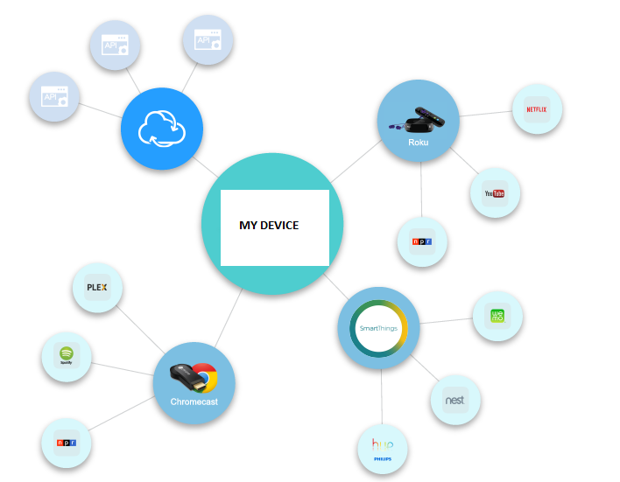

**Fig: 3 Poster showing capabilities of personal assistant named as “My Device”**

**Conclusion**

On the whole our idea of personal assistant can be very addictive to people to make use of it and can become part of your day to day activity. But updating it regularly about your remainders and the things, it can itself take care of your credit card payments, bills, grocery updates, online orders and so on. One of the important factor is the battery of the device should be long lasting and device can alert about low battery conditions. But, it is not a human to keep charge itself and is the limitation of the device.

We hope the idea of project can be kept into implementation given more amount of time as the project itself is a very huge project to deal with coding, hardware, software kind of things.

Also, proper marketing will certainly make the device more profitable for the firm who generate this and can be advertised on the web where people tend to look mostly.

**References**

* Team members for the project flow and diagrams
* <https://en.wikipedia.org/wiki/Amazon_Echo>
* Tofel, Kevin (July 9, 2015). ["Amazon Echo can now control Wink smart home products“](http://www.zdnet.com/article/amazon-echo-can-now-control-wink-smart-home-products/)
* ["Chi-Hua Chien"](http://www.crunchbase.com/person/chi-hua-chien). CrunchBase. 2012-01-24. Retrieved 2012-02-03.
* Empson, Rip (2011-07-29). ["Three Companies Chi-Hua Chien Of Kleiner Perkins Would Love To Invest In"](http://techcrunch.com/2011/07/29/three-companies-chi-hua-chien-of-kleiner-perkins-would-love-to-invest-in/). TechCrunch. Retrieved 2012-02-03.
* Chaudhri, Vinay; Cheyer, Adam; Guili, Richard; Jarrold, Bill; Myers, Karen; Niekrasz, John, [A Case Study in Engineering a Knowledge Base for an Intelligent Personal Assistant](http://www.adam.cheyer.com/papers/ontology-overview-semantic-desktop.pdf)